memorization ACTIVITY

DIRECTIONS
Have one group member upload this docx file to your Google Drive and share it with your groupmates and your instructor. Name your document “GroupX_Memorization” (where X is your group number). Work together to type up your responses to each question. Download your document as a PDF and submit this to your instructor.

BACKGROUND
Many times during the term, you may feel like your brain just cannot hold all of the information you are learning in your classes. Are there ways to improve our memories so that we can comprehend even more information? Research in cognitive psychology has suggested that the answer to that question is a resounding “yes”. This literature has suggested several strategies to improve memory, enhance recall, and increase retention of information.
One of the strategies identified by cognitive psychologists is that of chunking. Chunking refers to the process of taking individual units of information and grouping them into larger units (chunks). One common example of chunking occurs when we write and recall phone numbers. For example, a sequence of digits in a phone number, say 8-6-7-5-3-0-9, would be chunked into 867-5309.
In this activity, our class will perform an experiment and use the data collected to explore the following research ​​​​question:
Research Question: Is there evidence that chunking supports memorization more than non-chunking does?

THE MEMORY EXPERIMENT
- Now, while you are waiting for the data to be compiled and sent out to the class, let’s learn some new terminology. The first part of any analysis is to examine the observed data. These are the data that are actually observed in the research study, unlike data that is simulated in CODAP. In this study, we have data on two attributes for each participant in the study. What are the two attributes (two pieces of information) we have about each participant?
The two attributes we have for each participant are their group (chunking vs non-chunking) and their score on the memory test.

CHECK YOUR THINKING
The first attribute we have information about is the participant’s score (i.e., the number of letters recalled) from the memory experiment. This is called the response variable since it contains data on the subjects’ responses to the experiment.
The second attribute we have information about is the treatment condition that the subject was assigned to. This is called a treatment variable or grouping variable. In this research study the two levels of the treatment variable (the two conditions) are the experimental condition (chunking) and the control condition (no chunking).

- Is the treatment/grouping variable quantitative (numerical) or categorical? Was this the case in [a previous activity or problem on a difference in two proportions]?

The grouping variable is categorical. This was the case when dealing with two proportions as well.

- Is the response variable quantitative (numerical) or categorical? Was this the case in [a previous activity or problem on a difference in two proportions]?

The response variable is numerical, which is different from two proportions, where this is also categorical.

[These questions assume that you cover a difference in proportions before this, and highlight the distinction in the response variable changing from categorical to numerical, where the grouping variable remains categorical. The second part of this question can be deleted if this does not apply to you.]

Hopefully, the data will be available to you and your classmates now! Once it is, open that data in CODAP.

- Create a graph that illustrates the distribution of scores for the chunking (JFK) and non-chunking (JFKC) groups by placing the scores on the x-axis and the groups on the y-axis.

Your data will of course differ, but this looks at a sample class of 21 students.

- Paste the graph below.
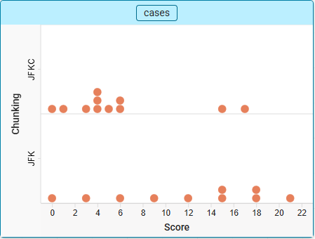

- Interpret what a dot in each of the graphs represents. Be specific and give an interpretation for one of the dots in the graph.

One dot in the plot represents one student in the class.

- Look at the graphs you constructed based on your classroom data.
- What do you notice about the two graphs?

For this graph specifically, there are a lot of dots clustered around low scores in the JFKC group, where the JFK was more spread out with many higher scores. Those in the JFK group also always scored in a multiple of 3, which makes sense given that the letters were always chunked in groups of 3.

- Describe any differences or similarities between the two graphs.

It is difficult to compare the overall shapes of the graphs with around 10 data points per group, but they both seem to be unimodal or have a primary cluster of observations – around 4-6 for JFKC and 15-18 for JFK. The scores definitely seem higher for the JFK group.

- Based on the scores in the two graphs, does it seem like there is an effect of chunking letters on memory (in other words, does it seem like the scores are higher for the chunking group than for the non-chunking group)? Explain.

It seems like there is a pretty stark difference in scores between the two groups, which would suggest that chunking has an effect on memory.

SUMMARIZING THE DIFFERENCE BETWEEN THE TWO CONDITIONS
- In order to answer the research question, you need to summarize the difference between the treatment and control conditions using a single number. How do you think you should calculate this single number?
Students may create many measures here. Ideally, they propose something that compares measures of center in the two groups, such as difference in means or medians.
Some may suggest just looking at one group’s measure of center – push back on this, as knowing one mean doesn’t give context as to how much better that group was at memory compared to no chunking.
When doing the simulation for the randomization test later, you can technically use a sampling distribution for one mean, as with sampling without replacement one group’s mean completely determines the other group’s mean. This will not be common for students to bring up here since the simulation part has not been thought through yet, but regardless, it makes more sense to have a statistic that better represents a comparison or baseline.
- Use CODAP to calculate this value.

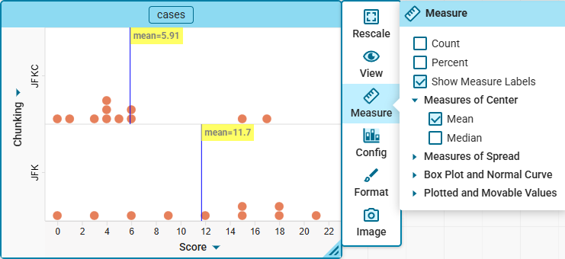

The difference in means is 11.7 – 5.91 = 5.79

- Interpret this value using the context of the memory study.

On average, students who memorized the letters with good chunks memorized 5.79 letters more than those who received the bad chunks.

- Before you conclude that chunking has an effect on memory, consider another alternative: the difference between the groups you saw in the observed data is solely attributable to experimental (chance) variation. Under this assumption, the observed difference is not because of chunking words, but rather because the random assignment to conditions/groups introduces variation into the results. If there is not an effect of chunking on memory, what would you expect the your calculated statistic to be? Explain.

If there were no effect here, then we would expect the score to be around 0, with the expectation that there may still be some differences occurring just by chance.

THE “NO GROUP DIFFERENCES” MODEL
To examine whether a result obtained in the observed data is solely due to chance (i.e., all the variation is due to random assignment), one approach is to imagine the scenario under which there is no difference in scores for the participants in the chunking and no chunking groups. In this particular context, assuming there is no group difference is the same as assuming chunking had no effect, whatsoever. Under this assumption or scenario, evidence would be collected to determine if the difference in means that was observed in the data is too large to probabilistically believe that there is no effect of chunking.
If chunking is truly ineffective, then each subject’s score on the memory test is only a function of that person and not a function of anything systemic, such as chunking. The implication of this is that, had a subject been assigned to the other condition (through a different random assignment), their score on the memory test would have been identical, in a sense, both conditions are doing nothing in terms of affecting the memory test scores.
- Write out a statement for the null hypothesis in this study.
The type of chunking you receive has no effect on the number of letters remembered, on average.

[The idea of no effect is important here, as the use of random assignment sets this up for causal inference.]

CALCULATING THE RANDOMIZATION TEST USING CODAP

AN OVERVIEW OF THE SIMULATION PROCESS
If there really were no effect of the chunking of letters on the scores, is it possible that random chance alone could have resulted in such an extreme observed difference between the two groups? Once again, the answer is yes, this is indeed possible. Also once again, the key question is how likely it would be for the random chance alone to produce experimental data that favor the JFK group by as much as the actual experimental data do. We will aim to answer that question using our simulation strategy:
- Model: We will assume that there is no difference between chunking and not chunking letters on the scores for the memory experiment. This is our null model.
- Simulate: We will replicate the random assignment process by randomly re-pairing the subject’s memory scores and the conditions (chunking and non-chunking) for the two groups. We will repeat this re-randomization process a large number of times, each time calculating a measure of how different the groups’ scores are in order to get a sense for what’s expected and what’s surprising.
  - With our null model’s assumption, we are essentially reproducing the randomization process done in the original sample, as using the scores of each participant essentially represents the participants themselves as we are assuming their scores will not change regardless of assignment.
- Evaluate: If the difference in the observed mean scores obtained in the experiment is in the tail of the null model’s sampling distribution, we will reject that null model.
- Discuss in your group how you might construct a sampler in CODAP that will allow you to simulate data to answer the research question of interest. As part of your work, be sure to:

- Copy and paste a picture of your CODAP sampler below.
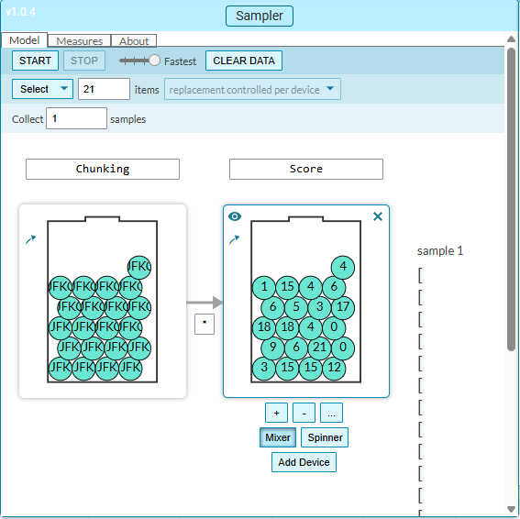
- Describe why you set the model up the way you did. In particular, please discuss how the model you constructed incorporates the ​​​​assumption made in the null ​​​​hypothesis (see Question 9).
The model is set up to take the group assignments and the scores, and re-assign them to each other by ensuring all items are selected via without replacement. This reflects the null by the fact that we are assuming this is a new random assignment with each participant receiving the same score regardless of group, which
- State what the select value is set to and explain why it is set to that value.
Select is set to 21 since there were that many students who participated in the memory study.
- Describe what elements you used to populate the device(s) in your sampler and why.
The elements in each device are the grouping assignments, and the scores for each student. These help represent the individuals and groups that were used in the original random assignment process we did in class.
- Describe if the device(s) in your sampler are set to with or without replacement and explain why.
The devices are set to without replacement to ensure that all students are given a new random assignment and so that the same totals in each group are used.

- Write out a brief description of the simulation process for each of the key parts of the memorization study:
- Describe what is happening when you run a single trial of the simulation and how this relates to the problem context.
When running a sample, the randomization process we did in class is emulated, with each students reassigned to a new group, assuming their score is unchanged.
- Run a trial of the simulation and make a graph of your output. Make your measure/statistic of interest visible on the plot. Paste your graph below.
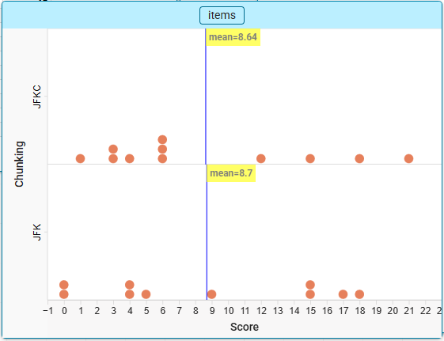
- Interpret what a dot in the graph represents.
One dot in this plot is one student in our class.
- Use CODAP to simulate the results of 500 trials and create a sampling distribution for the difference in mean/median scores between the chunking and non-chunking group.
- How does the sampling distribution for the difference in the mean/median scores help with answering the research question? Would it make sense in this case, to look at a sampling distribution for the mean/median of the chunking group only? Why or why not?
The difference in means or medians would allow us to have a measure that highlights how far apart typical scores are in each of the two groups. Just looking at the chunking/JFK group would give us an idea of how many letters those with good chunking can memorize, but we wouldn’t have the baseline of how well people can memorize letters that aren’t chunked well to understand the effect of chunking alone.
- Construct a graph of the sampling distribution. Copy and paste the graph of the sampling distribution below.
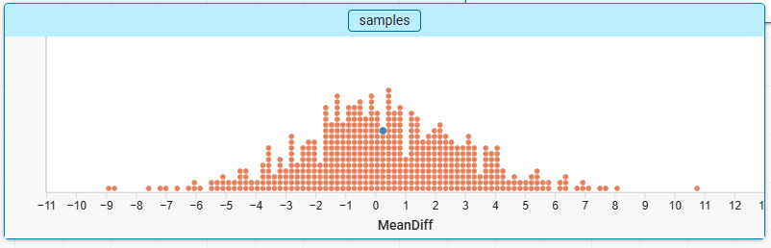
- Describe what a dot in this graph represents.
A dot represents a group of 21 students.
- Where is the center of the sampling distribution located? In light of the assumptions that you made when constructing your model (see Question 10b), does this make sense? Why or why not?
The center of the distribution is around 0, which makes sense given that this would reflect our null assumption of no effect.

- ​​​​​Based on the difference in the observed mean/median scores for the class experiment (Problem 6), what is the p-value? Please describe what the p-value means in the context of this problem.​
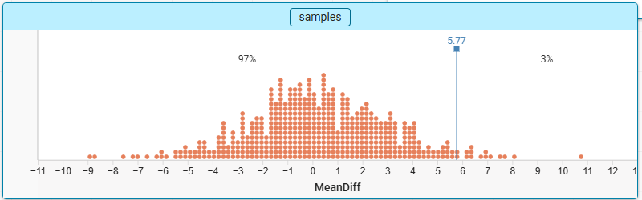
The p-value is 3%. This means that if there really were no effect of chunking, there would be a 3% chance that we would observe a mean difference of 5.79 or more just by random chance alone.

- Based on your response to Question 13, how strong is the evidence against the null model? What does this suggest about the answer to the research question?
This seems to imply moderate evidence (1-5%) against the null model. It doesn’t seem likely that random chance could produce these results if the null were true, but it plausibly could have been an unusual result too.

- What kinds of claims can we make about our data? Can we generalize our results to a larger population? Does this establish a cause-and-effect relationship? Why or why not?
Our classroom is not a random selection or necessarily representative of a larger population of students, so generalizable claims cannot be made from this study. But since we randomly assigned ourselves to different groups, any differences in our memorization abilities or other confounding factors should roughly balance out across the groups, meaning that we can better isolate the chunking as the cause for why we observed these differences.

